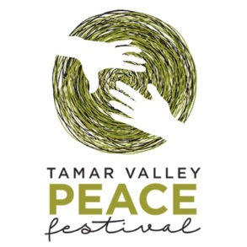
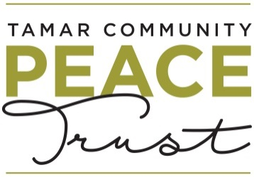

Sponsorship Prospectus
2023 Tamar Valley Peace Festival

We are pleased to offer you the opportunity to sponsor the 2023 Tamar Valley Peace Festival held from 17 -23 September 2023, incorporating the International Day of Peace on 21 September 2023.

The theme for the 2023 Tamar Valley Peace Festival is Connecting and Sharing (pathways to peace).

The Thought Leadership Event will be held on Thursday 21 September 2023 with Ms Rhoda Roberts AO as the key note speaker. Ms Robert’s address will be followed by a lively panel discussion exploring the theme of the power and potential of festivals to be a driver of positive social change through awareness, education and change and the opportunity this creates to build more peaceful communities.

This year’s festival will also include the Peace in Schools Program (PISP). The PISP is an initiative involving local community leaders who will engage with school students in conversations and activities about the concepts of peace and how young people can make a difference. This year’s guest speaker for the Peace in Schools Program is John Kamara, Australian Tasmanian of the Year.

In addition, the Trust will work with local community groups such as neighborhood houses so they can stage their own events that come from and support their communities. Over 20 community organisations are expected to participate in this year’s festival drawing an audience of approximately 1,500 people from throughout the greater Launceston community.

For example, these groups might
organise:
- an outdoor gardening/nature/care sustainability project
- creative arts (painting, writing, sewing)
- performing arts (singing, dance, theatre, poetry)
- cultural/communities centred around food, including
- cooking classes, ceremonies, gatherings
- physical activities such as bike riding and walking

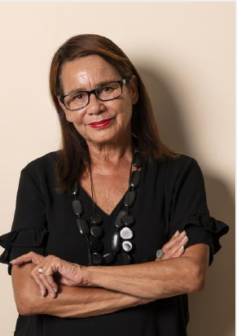
Below is an outline of the benefits of sponsorship:
Rhoda Roberts AO
Actor, Creative Director, Writer, Producer & Arts Consultant
Rhoda Roberts AO is a significant force on the Australian arts scene. A member of the Bundjalung nation, Widjabul clan of Northern NSW and South East QLD, Rhoda heads the First Nations Programming for the Sydney Opera House, is Festival Director of the Boomerang Festival / Bluesfest, Creative Director of the Parrtjima Festival (NT) and an Associate of Northern Rivers Performing Arts (NORPA).

A much awarded arts executive, Rhoda received an AO for distinguished service to the performing arts, leadership, advocacy and promoting contemporary Indigenous culture. In 2019, she was recognised with a Ros Bower Award from the Australia Council; in 2018, she received the Helpman Award – The Sue Nattrass Award; in 1998 she received a Deadly Award for Broadcasting.

 | $1,000 | $2,500 | $5,000 | $10,000 or higher
Logo/name in Peace Festival flyer (1,500 copies)
Logo/name on Peace Festival web site
Logo/name on Peace Festival facebook page
Acknowledgment in all media releases
Verbal acknowledgment at all events attended by the Trustees
2 x Complimentary tickets to the thought leadership event – RSVP required
Logo and acknowledgement on online booking page for ticketed events staged by the Trust
Display of your banners/signage at the thought leadership event (supplied by you)
Other elements as agreed in the funding/sponsorship agreements

Please complete the following section to confirm your support:

Name of Company
Contact Person
Telephone/Email
Address (billing)
Signature

Confirms our support of the Tamar Valley Peace Festival (please tick the appropriate box)

 | $1,000 | $2,500 | $5,000 | $10,000 or higher
Cash
In Kind

John Kamara

Humanitarian and co-founder, Culturally Diverse Alliance of Tasmania and African Communities Council of Tasmania

TAS STATE RECIPIENT AUSTRALIAN OF THE YEAR 2023
John Kamara escaped war-torn Sierra Leone 19 years ago and started a new life in Tasmania in 2004. He now does all he can to assist migrants, refugees and people from culturally diverse communities.
His own experiences and work in child protection mean he understands the challenges new arrivals and marginalised groups face.
Sitting on multiple boards and involved in many community groups, John highlights systemic disadvantages for migrants such as racism, labour exploitation and recognition of overseas qualifications. He also assists with migrants’ resumes and their search for jobs and housing.
John co-founded the Culturally Diverse Alliance of Tasmania to support education and promote social cohesion, as well as the first ever African Communities Council of Tasmania

