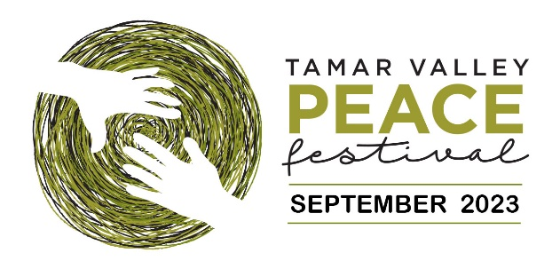

Inviting young people to think about, and discuss, Peace.
Tamar Valley Peace Festival, 2023
Celebrating the International Day of Peace

Everyone is invited to host activities that demonstrate their way of creating goodwill and a
harmonious, safe and welcoming community. This year’s theme is “connecting – sharing: pathways to peace”.

Tamar Valley Peace Trust invites school students to make a promise to Peace; to write a message or draw an image of what Peace means to them.

We have created a Peace Dove template (attached) on which students can write a message, create
an image or colour in. Once students have finished being creative with their Peace Dove and cut them out, please display them at your school.

To do:
- Discuss Peace in class. This could be as simple as reading a book or watching an appropriately themed movie.
- Print enough doves for your students.
- Encourage students to express what peace means to them by writing or drawing or colouring the dove. Doves could be displayed on class windows; in which case they could have a message or drawing added to both sides.
- Ask students to cut out the dove.

When your displays are in place, we would love you to send photos of the students work to be displayed on the Tamar Valley Peace Festival website. Due to student privacy and the works being displayed online, it is an individual choice regarding the inclusion of the student’s name.

We urge you to engage your students in this process and a discussion about peace – and the concept. of non-violent conflict resolution. Students may define peace in a range of ways – maybe the absence of bullying, war or domestic violence – or greater cultural or environmental harmony. The lens they use does not matter: the goal is to think about how they, as individuals, can help create a kinder society.

We look forward to seeing the wonderful doves the students create.

The Peace Festival runs from 17th- 24th September. However, we would love to receive any images you may have of the students work before this date to showcase on the website.

Visit Tamar Valley Peace Festival website to learn more about the
Peace Trust and Festival

http://www.tamarcommunitypeace.org.au/

PH: 0417 892 884 FB: Tamar Peace Festival Community page

